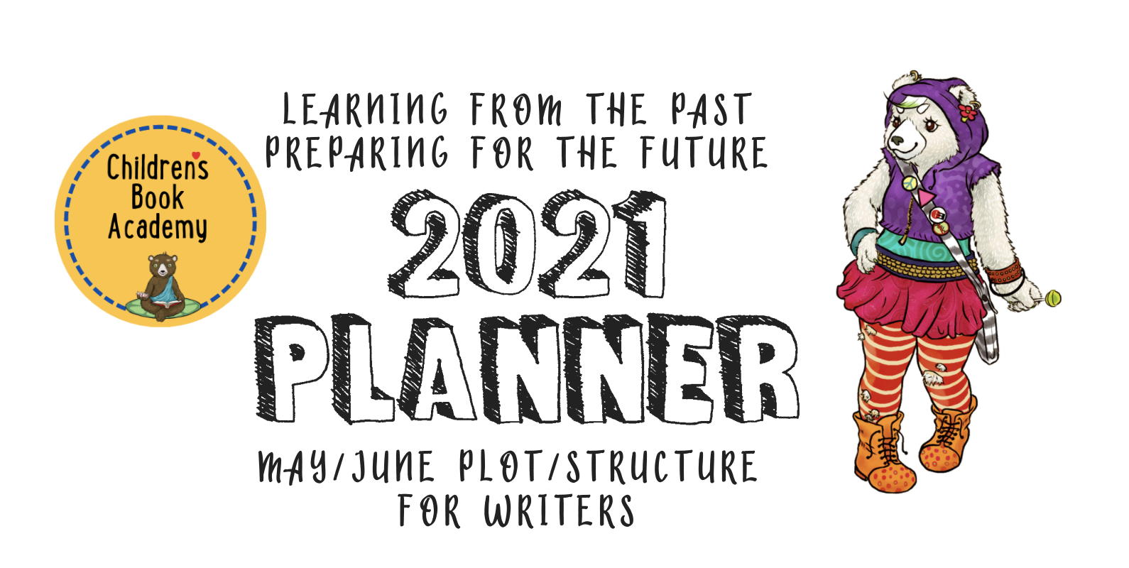
“Creativity takes courage.” – Henri Matisse

May/June for Writers (we will be alternating months between Writers and Illustrators).

This time around, we are going to focus on different kinds of fiction structures. We’ll be doing illustration in June/July and nonfiction later in July/August.

Whatever you’re writing, what are the main story elements? Use these suggestions, and feel free to add more of your own. We’ll be looking at some different fiction structures starting with the classic plot-driven three-act structure.

Let’s start with that. These narratives, whether true or imagined, all follow the same structure of a beginning, a middle, and an end. But in order to make the plot really exciting, we need conflict and resolution. Another way to think of it is in terms of an equation of CHARACTER + GOAL + OBSTACLE = CONFLICT. So, to tease out and develop this, write some ideas using the following prompts:

Who is/are your main characters and why do we care about them?

What is the Setting/backstory?

What are the main character’s Goals or Motivations for their journey through the story?

List 3 of your character’s main flaws and 3 of the obstacles that they encounter on their journey related to their flaws

How might your MC fail to overcome each of these obstacles and ultimately triumph?

How does this triumph show in the ending?

What are the underlying themes, i.e. what underlies the surface story of the journey e.g. saving a friendship or teamwork wins or ...?

What makes your story unique?

What is the takeaway for kids after they read this book?

Next up, let’s look at some other structures that will help lead your reader from the beginning of the book to the end. Try telling your story with each of these structure prompts:

Geographic (Through a neighborhood, Through a home, Through a school and school yard, a Park, From East to West or West to East or North to South etc., Country to Country etc.)

Abstract concepts (counting, alphabet, colors, etc)

Chronological (times of days, seasons, days of the week, months of the year, etc)

Thematically linked objects (toys, bathtub stuff, kitchen stuff, clothes, transportation, etc)

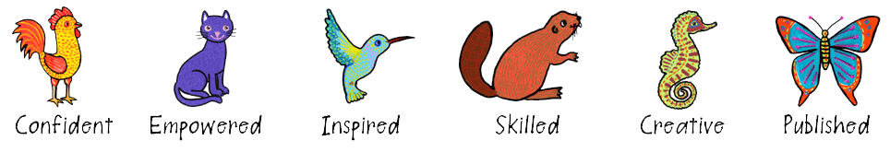

Let’s do some more mind mapping in terms of themes; the possibilities are endless. Concept books can include all of the above plus counting books, alphabet books, colors, the body, animals, seasons, food, daily routine, objects, seasons, days of the week, etc.. Which of these (or write your own) comes closest to capturing the theme (or concept) of your book, character, or subject matter?

Quest
Rebirth
Overcoming
Rags to riches
Voyage and return
Family (belonging, protecting, new family family members, whacky family members...)
Dealing with emotions (anger, sadness, jealousy, insecurity..... )
Facing fears
Play
Imagination
Gender identity
Discovering something new
Moving
Loss
New beginnings
Friendships (and their complexities)
Teamwork and co-operation
Foods (eating stuff you don't like)
Starting school
Fear of failure
Overcoming difficulties
Loving and/or caring for pets
Fascination with animals
Creativity
Fitting in (insider or outsider)
Bullying
Cycles of life
Seasons of nature

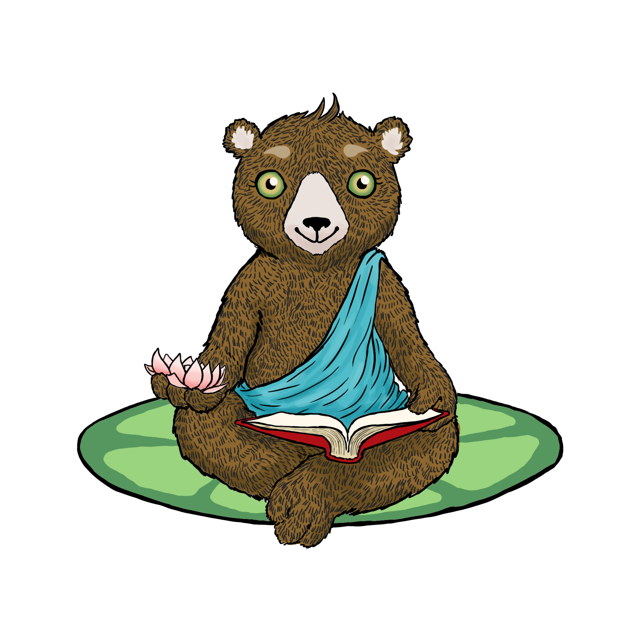

RESEARCHING, TARGETING, AND SUBMITTING
TO YOUR IDEAL EDITOR, ART DIRECTOR OR AGENCY

Keep researching and finding the names of 5 or more editors, agents, or publishers you would love to work with. What books have they worked on or represented that you like? Why do you want to work with them specifically?

1.

2.

3.

4.

5.

Use this one or create a new table with the names of who you are sending your work to, their email, agency or publisher, planned submission date, actual submission date, response. If you don’t hear back from them within 3 months, follow up. Remember to also put these dates with reminders in your calendar, as well.

Name | Email | Agency  Publisher | Planned submission date | Actual submission date | Response | 3-month follow up

“Creativity is allowing yourself to make mistakes. Art is knowing which ones to keep.” – Scott Adams

If you are up for it, let us know how you’re doing with these planners. xoxox

