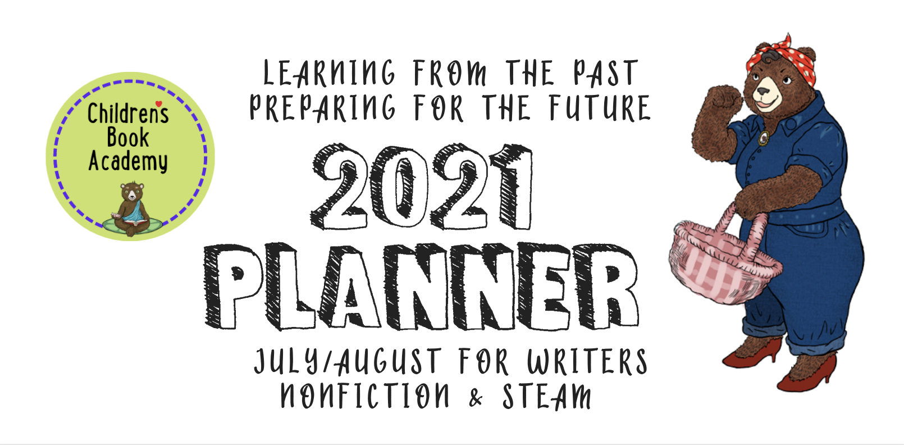

“Creativity is magic. Don’t examine it too closely.” – Edward Albee

We hope you’ve been loving these planners, which we’ll be turning into either a book or a very special course next year. This one is dedicated to writing Nonfiction, Biographies, and Informational Fiction with juicy structures and STEAM foci.

As you probably know, nonfiction is hot. And writing it can be fantastic fun! First off you need to choose a really juicy topic or subject that will fascinate kids.

Who or what is your subject or topic and why is it, or are they, fascinating and important?

Next up, experiment with different structures for your nonfiction book. Using these as prompts, how would you organize your plot according to the following way of presenting your book:

Description This might be geared for younger readers and gives a detailed description of someone or something’s internal and external qualities with perhaps an arc or foundational structure such as what a particular bird goes through migrating from North to South for the winter or ...

Cause and Effect This can be especially useful for science: offering up ideas about how blackholes exist or why whales blow water when they surface or how something came to be invented.

Comparison/Contrast This structure is especially useful in nonfiction when the character or subject matter is placed in context in order to look at similarities and differences between people, events, ideas, or whatever. For example: How are the Spanish colonists related to and different from the Incans? How was Alexander Hamilton different from George Washington?

Order/Sequence This is an oldie but a goodie and the way nonfiction was typically organized until more recently. A book about Langston Hughes would give the reader a chronological list of dates or events, or another might tell us the steps in building a birdhouse, for example. An alphabet or counting book would also use this structure.

Problem/Solution Find a problem, like climate change, and discuss or go over possible solutions (and causes).

Plot-driven Contemporary biographies used to be birth to death stories but these days they tend to be much more plot-driven stories focused on the drama of a specific incident that made them famous or defined why they were (or are) or should be, an important figure. They often begin with something in childhood that shows their beginning interest or the reason they grew up to become who they became. If you are going the plot-driven route, write down a possible title and what they became known for, or should be known for, three things that got in the way of achieving their goal and what enabled them to triumph and how that impacted others.

Whichever way you are writing your nonfiction, it’s important that the story comes first, that all your facts be verifiable, and that you don’t include too many facts in your story so that it’s an information dump. Instead save some of those juicy facts for the back in what’s called backmatter. Finally, I want to mention the wonderful world of informational fiction (one of my favorites).

You’ll often find anthropomorphized characters leading the way in informational fiction, which usually focuses on a nonfiction topic but also features plot-driven (or not) stories or arcs that make the story much more entertaining through fictional elements.
STEM is short for science, technology, engineering and math curriculum choices, while STEAM represents STEM plus the arts. However, the arts are usually given short shrift. STEAM investigates these concepts, but does this through inquiry and problem-based learning methods used in the creative process. Since most of us using this planner are probably more left brain than right, this bit might be a little bit of a challenge, but give it a try.

Which of the sciences would you most like to write a children’s book about? Some really popular ones include zoology, biology, chemistry, physics, botany, etc.
Do a little google search and pick your favorite field of science and a potential book topic. How might you make it fun and interesting?

What about technology? What field would you be most inclined toward? Think about architecture, computers, medicine, products, business, etc.

Do a little google search and pick your favorite field of technology and potential book topic. How might you make it fun and interesting?

Engineering can be fun! What about environmental engineering, chemical engineering, mechanical engineering, civil engineering, etc.
Do a little google search and pick your favorite field of engineering and potential book topic. How might you make it fun and interesting?

Don’t roll your eyes at mathematics: there’s algebra, geometry, logic, number theory, abstract, etc.
Do a little google search and pick your favorite field of math and potential book topic. List any topics that you might be intrigued enough to write about. How might you make it fun and interesting?

And now, everyone’s favorite--art. Which ones are you most interested in: dance, music, painting, sculpture, literature, etc.?
Do a little google search and pick your favorite field of art and potential book topic. How might you make it fun and interesting?

RESEARCHING, TARGETING, AND SUBMITTING
TO YOUR IDEAL EDITOR, ART DIRECTOR OR AGENCY

Keep researching and finding the names of 5 or more editors, agents, or publishers you would love to work with. What books have they worked on or represented that you like? Why do you want to work with them specifically?
1.

2.

3.

4.

5.

Use this one or create a new table with the names of who you are sending your work to, their email, agency or publisher, planned submission date, actual submission date, response? 3 month later follow up. Remember to also put these dates with reminders in your calendar, as well.
Name | Email | Agency  Publisher | Planned submission date | Actual submission date | Response | 3-month follow up

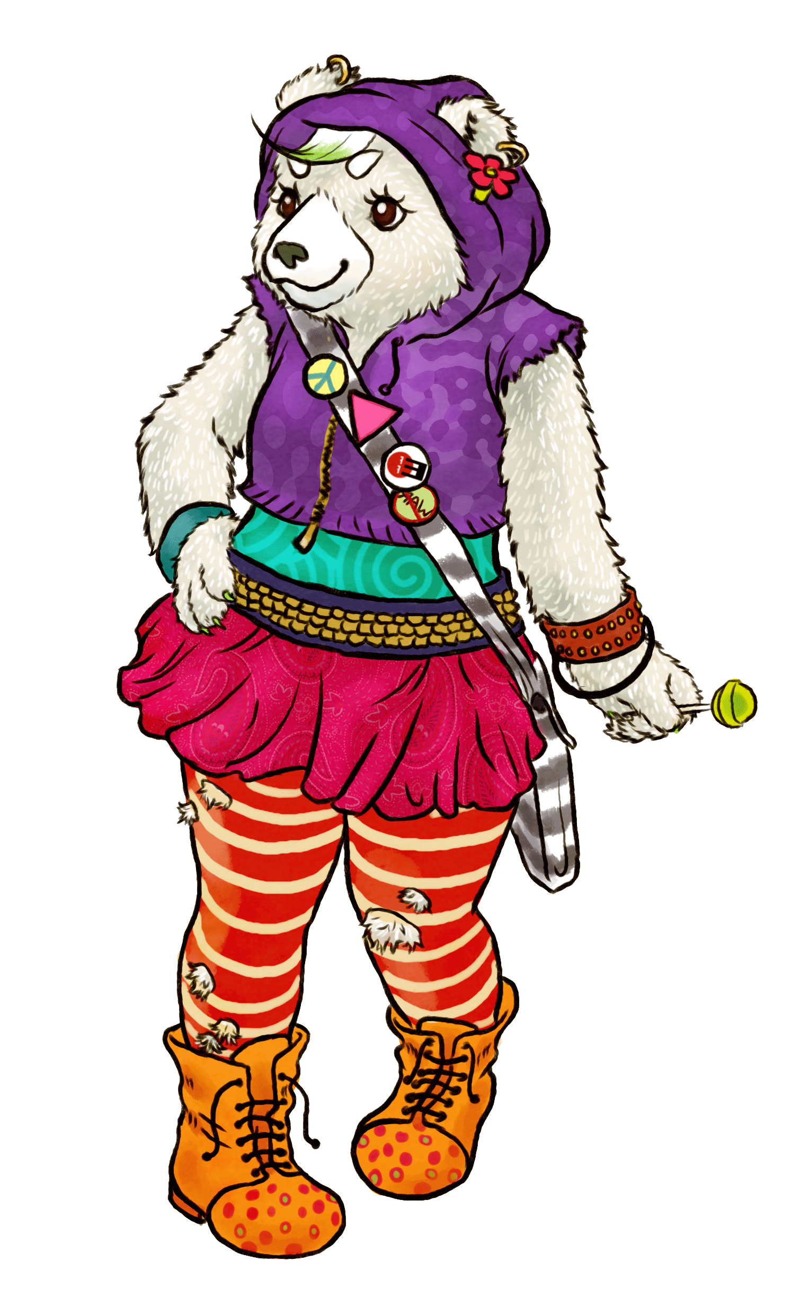Have fun!!!!

