June/July for Illustrators (we will be alternating months between Writers and Illustrators)

“Every artist was first an amateur.” – Ralph Waldo Emerson
MAKE IT MOVE!!! CONTRAST AND COLOR
Hi there and welcome to another handy dandy planner. We sent something similar in one of our newsletters but this planner gives you more opportunities to put those ideas into practice. If you haven’t already, please make a folder called something like “CBA 2021 Inspirational and Practical Planner” for these and copy and paste each month’s worksheet to combine as you go. Then at the end of the year, pull the worksheets out and copy and paste them into one doc to see how well you did and what you might want to carry over or follow up on.

MOVEMENT

In general, the antidote to boring is movement. As you illustrate your characters, make them move, give them action, give them agency, give them lots of life (agency means power in and over their own lives). Show us through movement, whether big or small, what’s going on with actions that mirror your character’s emotions. Create wonderful negative space, which is the space between and around whatever is happening on your page whether it's illustration or writing both for aesthetic reasons and to give your reader/viewer plenty of space to breathe.

Draw three characters with deliberately curved lines on them (these can be the same character in different poses. Envisioning a single line overlaying your drawing can be a simple way of creating a feeling of movement. Try to avoid a perfectly straight vertical or horizontal line of action, which may make a drawing feel static.

Now contrast straights and curves by drawing three characters side by side with a balance of straight and curved lines invigorating the illustration. For example, contrast the use of a straight line for a character’s back with the soft curve showing their stomach. Or try a curving back with a flat stomach or both curving back and curving stomach. See which you like best.

Try titling and or twisting your characters into different twisted positions. Have them bend at the waist, turn around, look over their shoulders, etc. or bend at the knees reaching down or around.

Try experimenting with different shapes by drawing the same characters composed of different shapes. For example, try drawing a dog made up of square shapes, then try circles, and then again with triangles, or whatever.

Try distorting your characters: draw three versions (focusing on faces here can be helpful): one is squashed, one is stretched, and one uses both.

Draw your character holding, carrying, or pushing something. Try 3 versions: in one, the thing is heavy, in another, the thing is light, in another the thing is slippery or gelatinous.

Let’s work a little with negative space. Try drawing three poses (maybe holding something or running, etc) for your characters in full silhouette. Do some of them work better than others?

Which emotions relate to which colors in your imagination? Draw 3 abstract emotions that are either simplified or in detail, or draw three characters experiencing those emotions.

Draw a living animal, or animals, made out of something else— things like a snake made out of stone, a cat made out of ice, a bat made of gears, a dinosaur made of legos, a bird made out of darkness. Go wild and do whatever you like with this.

Create a short comic, at least three panels in length. It can be as simple or as complicated as you’d like! The point of this prompt is to work on conveying a sense of progression, a sense that something has happened.

Pick three physical action verbs and draw your character in motion. Ask others to see if they can guess your verbs based on your illustrations. Based on feedback, do you need to tweak your drawings?

Pick your favorite three drawings so far in this session and render them in the three different palettes that are randomly generated at https://coolors.co/d4e09b-9cb380-94a89a-c7ac92-a44a3f.
RESEARCHING, TARGETING, AND SUBMITTING TO YOUR IDEAL EDITOR, ART DIRECTOR OR AGENCY

Do a bit of research and find the names of 5 or more editors, agents, or publishers you would love to work with. What books have they worked on or represented that you like? Why do you want to work with them specifically?
1.

2.

3.

4.

5.

Use this one or create a new table with the name of who you are sending your work to, their email, agency or publisher, planned submission date, actual submission date, response? 3 month later follow-up. Remember to also put these dates with reminders in your calendar, as well.
Name | Email | Agency  Publisher | Planned submission date | Actual submission date | Response | 3-month follow up
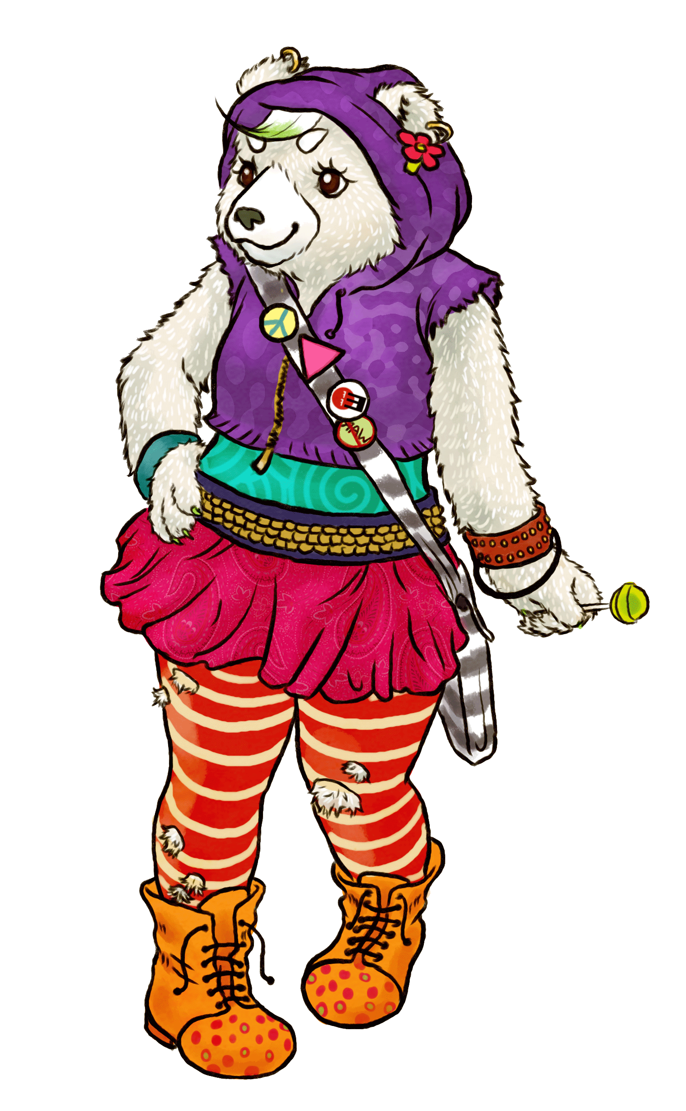
Have fun with this, and as Marsha Diane Arnold says, think of it as a playsheet rather than a worksheet.

