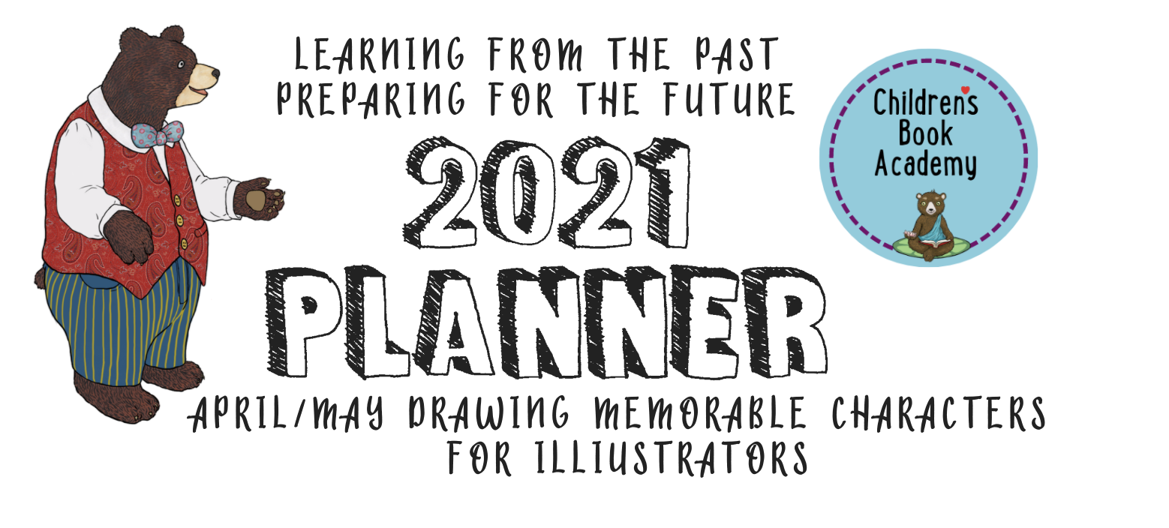
April/May for Illustrators (remember we alternate months between Writers and Illustrators)

Pump Up Your Portfolio with Memorable Characters

Hi there and welcome to your 2nd illustration planner, which you might find handy even if you consider yourself solely a writer. If you haven’t already, please make a folder called something like “CBA 2021 Inspirational and Practical Planner” for these and copy and paste each month’s worksheet to combine as you go. Then at the end of the year, pull the worksheets out and copy and paste them into one doc to see how well you did and what you might want to carry over or follow up on.

INSPIRATION

What were your 6 favorite books in terms of illustrations in 2020 that inspired you in terms of memorable characters?
Be sure to include as many of the following details as possible: the title, author, illustrator, subject, materials, genre, underlying themes, page number, word count, publisher. What did you like most about the characters in each one? Can you figure out what materials and techniques they used? What is it about those characters features and body language that exemplified the character’s personalities and experiences? Try and have a range of different approaches below.

1.

Search for this book on Google images and Copy and Paste an inspirational image from the above book below. Don’t worry how the formatting of this planner changes.

2.

Copy and Paste an inspirational image from the above book below:

3.

Copy and Paste an inspirational image from the above book below:

4.

Copy and Paste an inspirational image from the above book below

5.

Copy and Paste an inspirational image from the above book

6.

Copy and Paste an inspirational image from the above book

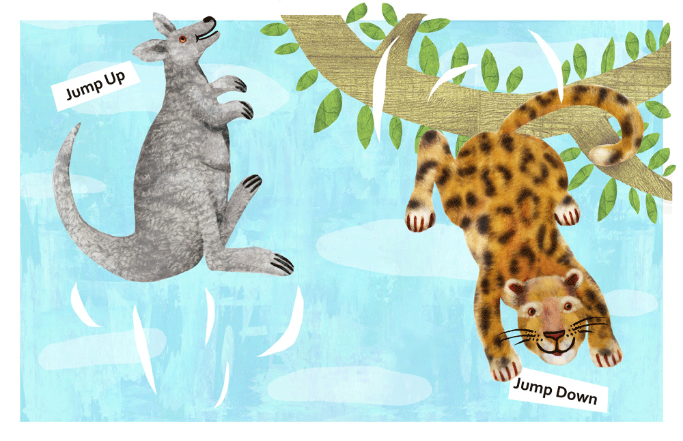

Starting or Improving Your PORTFOLIO with Your Own Memorable Characters

For this illustration worksheet, we’ll be focusing on: Creating Memorable Characters. Let’s begin by drawing, copying and pasting or printing out and cutting and pasting your character--choose one of your own stories or something from the public domain (here are possible sources: https://inspiredpublic.com/fairy-tales-with-illustrations-online-in-the-public-domain/ http://free-universe.myartsonline.com/literature.html )

Now based on your analysis of your favorite character illustrations, see how you can tweak your own character illustrations without plagiarizing. Is there a way you could redraw the nose or ears or their body language, or how they move to give yours more character?

Next up, try drawing your character in the round, meaning try drawing them front on, from the side, three quarter view, and from behind. If you are working digitally, just draw the first character and then copy and paste it for each version, add another layer and make the changes for each of the different views to keep your proportions consistent.

Let’s work on developing a character sheet. Use all your senses for this character: what do they sound, smell, feel, or even taste like? Where do they live? W ho do they hang out with? Bear in mind the target age of both your audience and your character. Styles for children’s characters can run the gamut from realistic, full of details to very simplified, child-like, naive drawings.

What kind of visual structure, technique or style do you think would work best to make this character distinctive? If you can’t put the style into technical words, make a reference to an author/illustrator who you are inspired by.

For each of the following prompts try at least 2 or 3 versions. (Feel free to use the back if you get inspired and need more space.)

Different expressions?

Different poses?

Different outfits?

Who do they hang out with? What do their family and friends look like?

Different settings (maybe someplace they’d be really uncomfortable and another place they’d feel right at home)?

Try exaggerating features or body parts to make them express their inner personalities more? Can they be more funny, tragic, sympathetic, quirky, or physically distinctive?

Let’s work more with the character in a larger and more experimental context. How can you destabilize the image to make it more interesting with more negative space (the space around and between the character)?

Can you emphasize diagonal lines and planes (rather than just vertical and horizontal ones)?

Create a Sequence of three angels showing you character doing different things to show you can keep your character consistent. Make sure to show some movement.

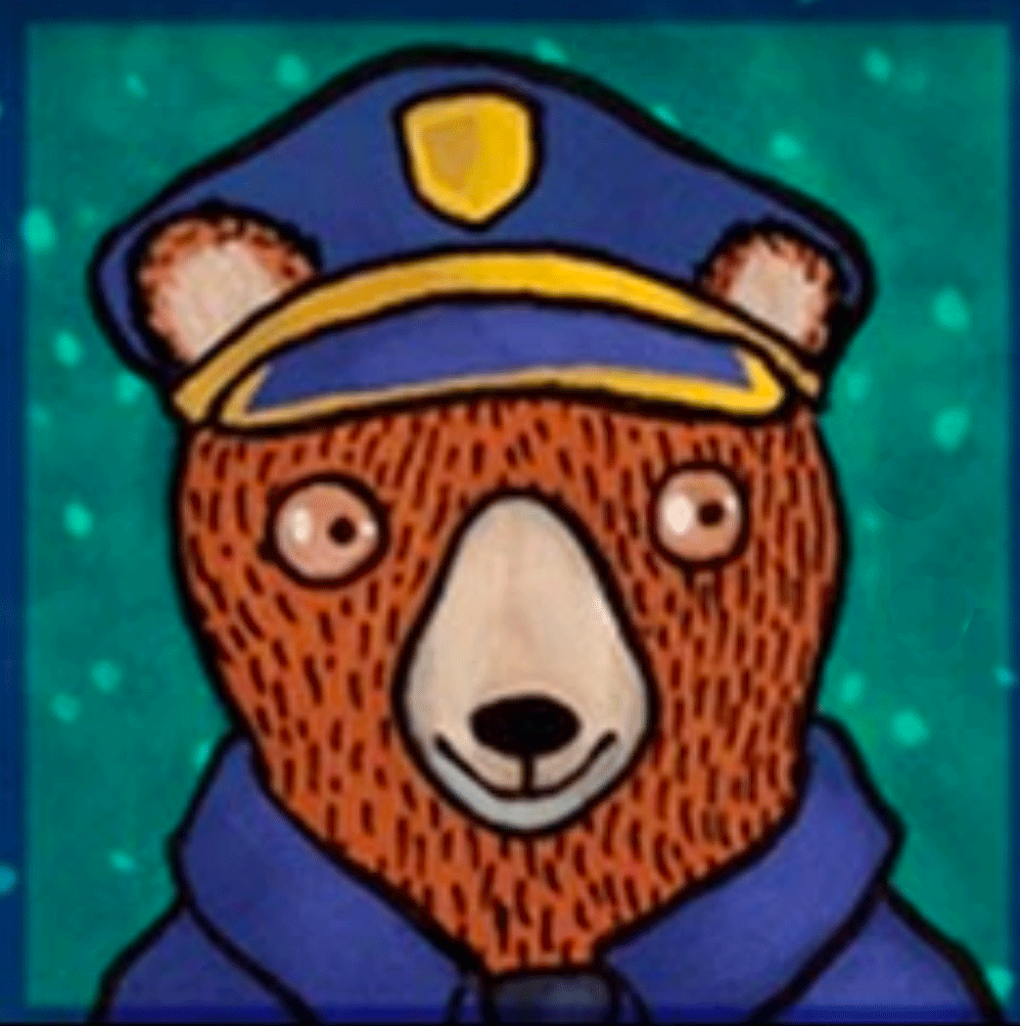

Try using at least a couple of other styles or techniques or color palettes, etc to portray your character and push your boundaries. If you used something really modern, try a style that is older and more traditional or retro. If you used something really realistic, try something stylized. If you imagine a lot of color, try black and white. If you were going soft with a watercolor effect, try a hard-lined pen & ink drawing or Anime. If you were going to draw by hand, try Procreate if you have it. The possibilities are endless (and you can do a quick google search for KidLit cover art for inspiration).

Style 1

Style 2

Style 3

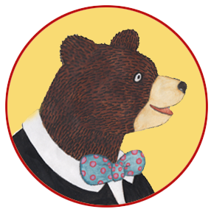
Now think about your character in context: how can you create visual suspense or page turns (something that bleeds off the page, a hint of what’s to come)?

In terms of plot, how are the character’s obstacles, flaws or fears going to be rendered?

What are your illustrating super strengths in terms of creating and developing this character?

And what could you improve to make this character more memorable?

KEEP RESEARCHING AND TARGETING YOUR IDEAL EDITOR, ART DIRECTOR OR AGENCY WHO YOU WILL BE SUBMITTING YOUR WORK TO

Do a bit of research and find the names of 5 or more editors, agents, or publishers you would love to work with. What books have they worked on or represented that you like? Why do you want to work with them specifically?

1.

2.

3.

4.

5.

Use this one or create a new table with the name of who you are sending your work to, their email, agency or publisher, planned submission date, actual submission date, response? 3 month later follow up. Remember to also put these dates with reminders in your calendar, as well.

Name | Email | Agency  Publisher | Planned submission date | Actual submission date | Response | 3-month follow up
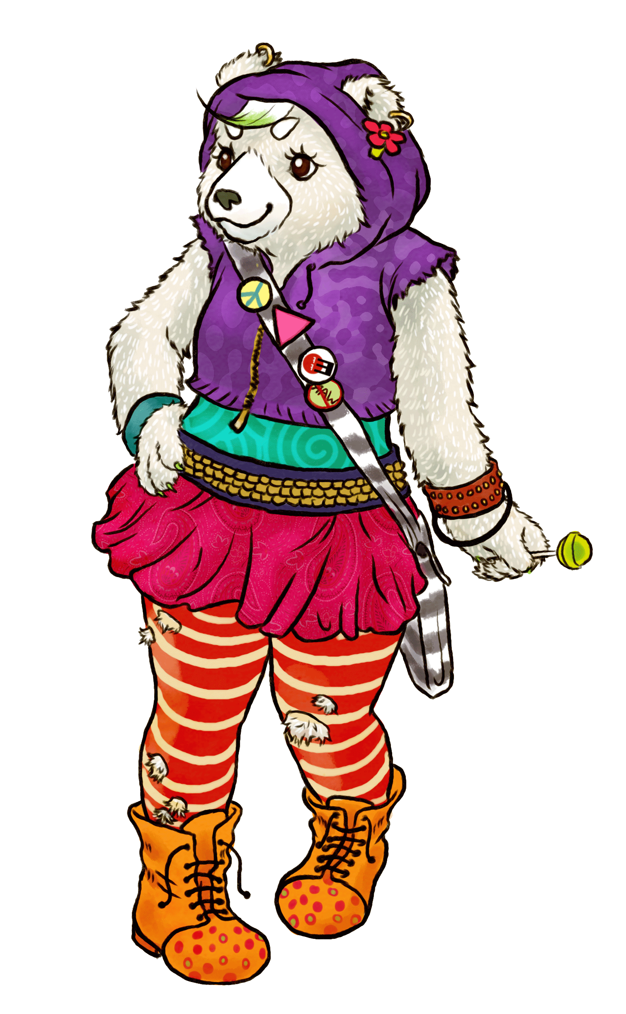Have fun!!!!

