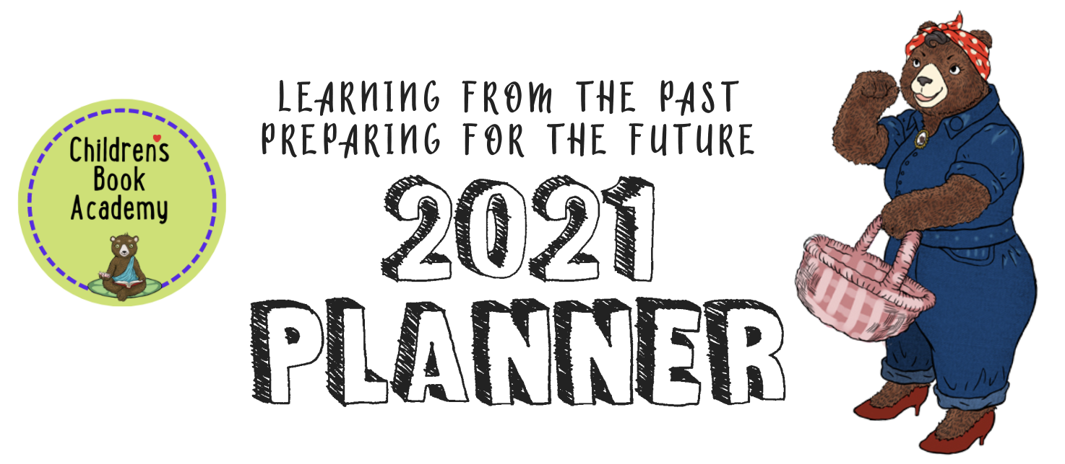

January/February for Writers (we will be alternating months between Writers and Illustrators where you can each learn from each other and double bonus for writer/illustrators and feel free to change the months as needed!).

Please make a folder called something like “CBA 2021 Inspirational and Practical Planner” for these and copy and paste each month’s worksheet to combine as you go. Then at the end of the year, pull the worksheets out to see how well you did and what you might want to carry over or follow up on.

2020 was a killer year and yet most of us kidlit creatives learned a whole lot from it, especially in terms of craft with ideas and dreams for the future so let’s look at 2020 quickly and then move onto planning 2021 to get the most out of it!

What were your 6 favorite books in 2020?
Be sure to include as many of the following details as possible: the title, author, illustrator, subject, genre, underlying themes, page number, word count, publisher.
What did you like most about each one?

List your own top ten 2020 kids book ideas here or write 10 quick ideas right now. Note any ideas that you liked above that you could incorporate with your own ideas and make different
1.

2.

3.

4.

5.

6.

7.

8.

9.

10.

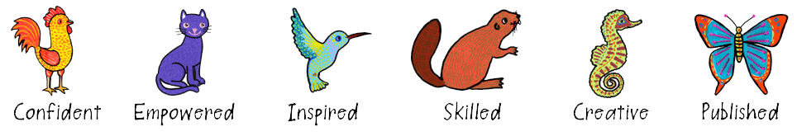
Now pick one from your own KidLit ideas to narrow down and focus on for January and February. We want you to break this one idea down into smaller, more manageable steps but first let’s do some research.

What is your favorite idea, with a working title?

What are some similar books also known as comparables or comps?

What makes yours different/unique or different?

Who is your main character (or characters)? Or for nonfiction what is your subject?

What makes them or it memorable, fascinating, or important?

What makes us care about your characters or subject enough to want to stay with them throughout the book?

With fiction or biography, what is the initial problem goal or inciting incident that sets the main character off on their journey and intrigues the reader to turn the page and keep on reading?

What are three escalating obstacles that get in the way of the main character or characters in solving the problem or attaining their goal?
1.

2.

3.

With concept books and nonfiction, what angle or structure are you using, or can you use, to make your manuscript more unique, entertaining, or compelling?

What kind of language/voice will you be using for your author's voice and how you tell the story (ironic, heartfelt, funny, British style (which usually goes with irony), lyrical, self deprecating, insecure, or unreliable etc.)? Include some favorite words here or phrases that you might use as the narrator or that your characters might use.

What kind of voice will each character have to make them distinct individuals? Include their names and some words or phrases they might use.

What are your writing or illustrating super strengths in this project or in general?

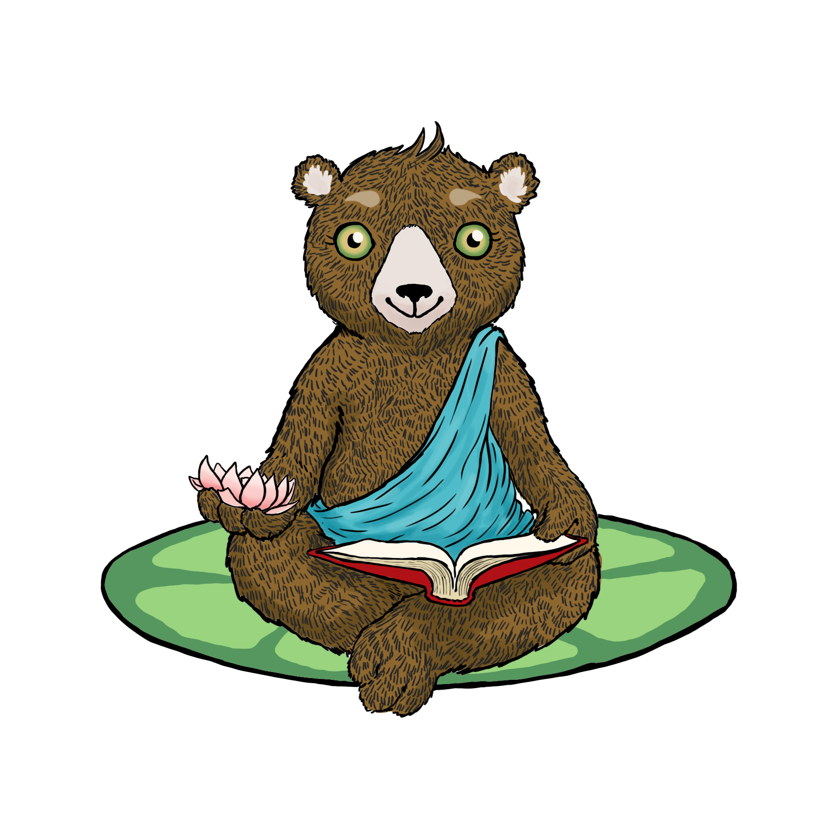
And what are your weaknesses in this particular manuscript?

CHARACTER
How can you strengthen and make your character or characters or subject more…
Memorable:

Funny or tragic:

Sympathetic:

Quirky:

Flawed:

How can you amp up the drama and raise the stakes by creating a more important inciting goal or problem to solve in the beginning (important to the main character - interior or exterior? Or their world at large)?

PLOT
How can you raise the stakes to amp up the drama with successively more difficult obstacles and fails preferably related to the main character’s flaws or fears?
List each one with escalating ideas:

How can you create page turns pretty much forcing the reader to turn the page like a television series does at the end of each episode?

And how do they ultimately achieve their goal or solve the problem and what are the consequences (i.e. wrapping up loose ends, walking the story ending back to the beginning to create a satisfying ending or ….)?

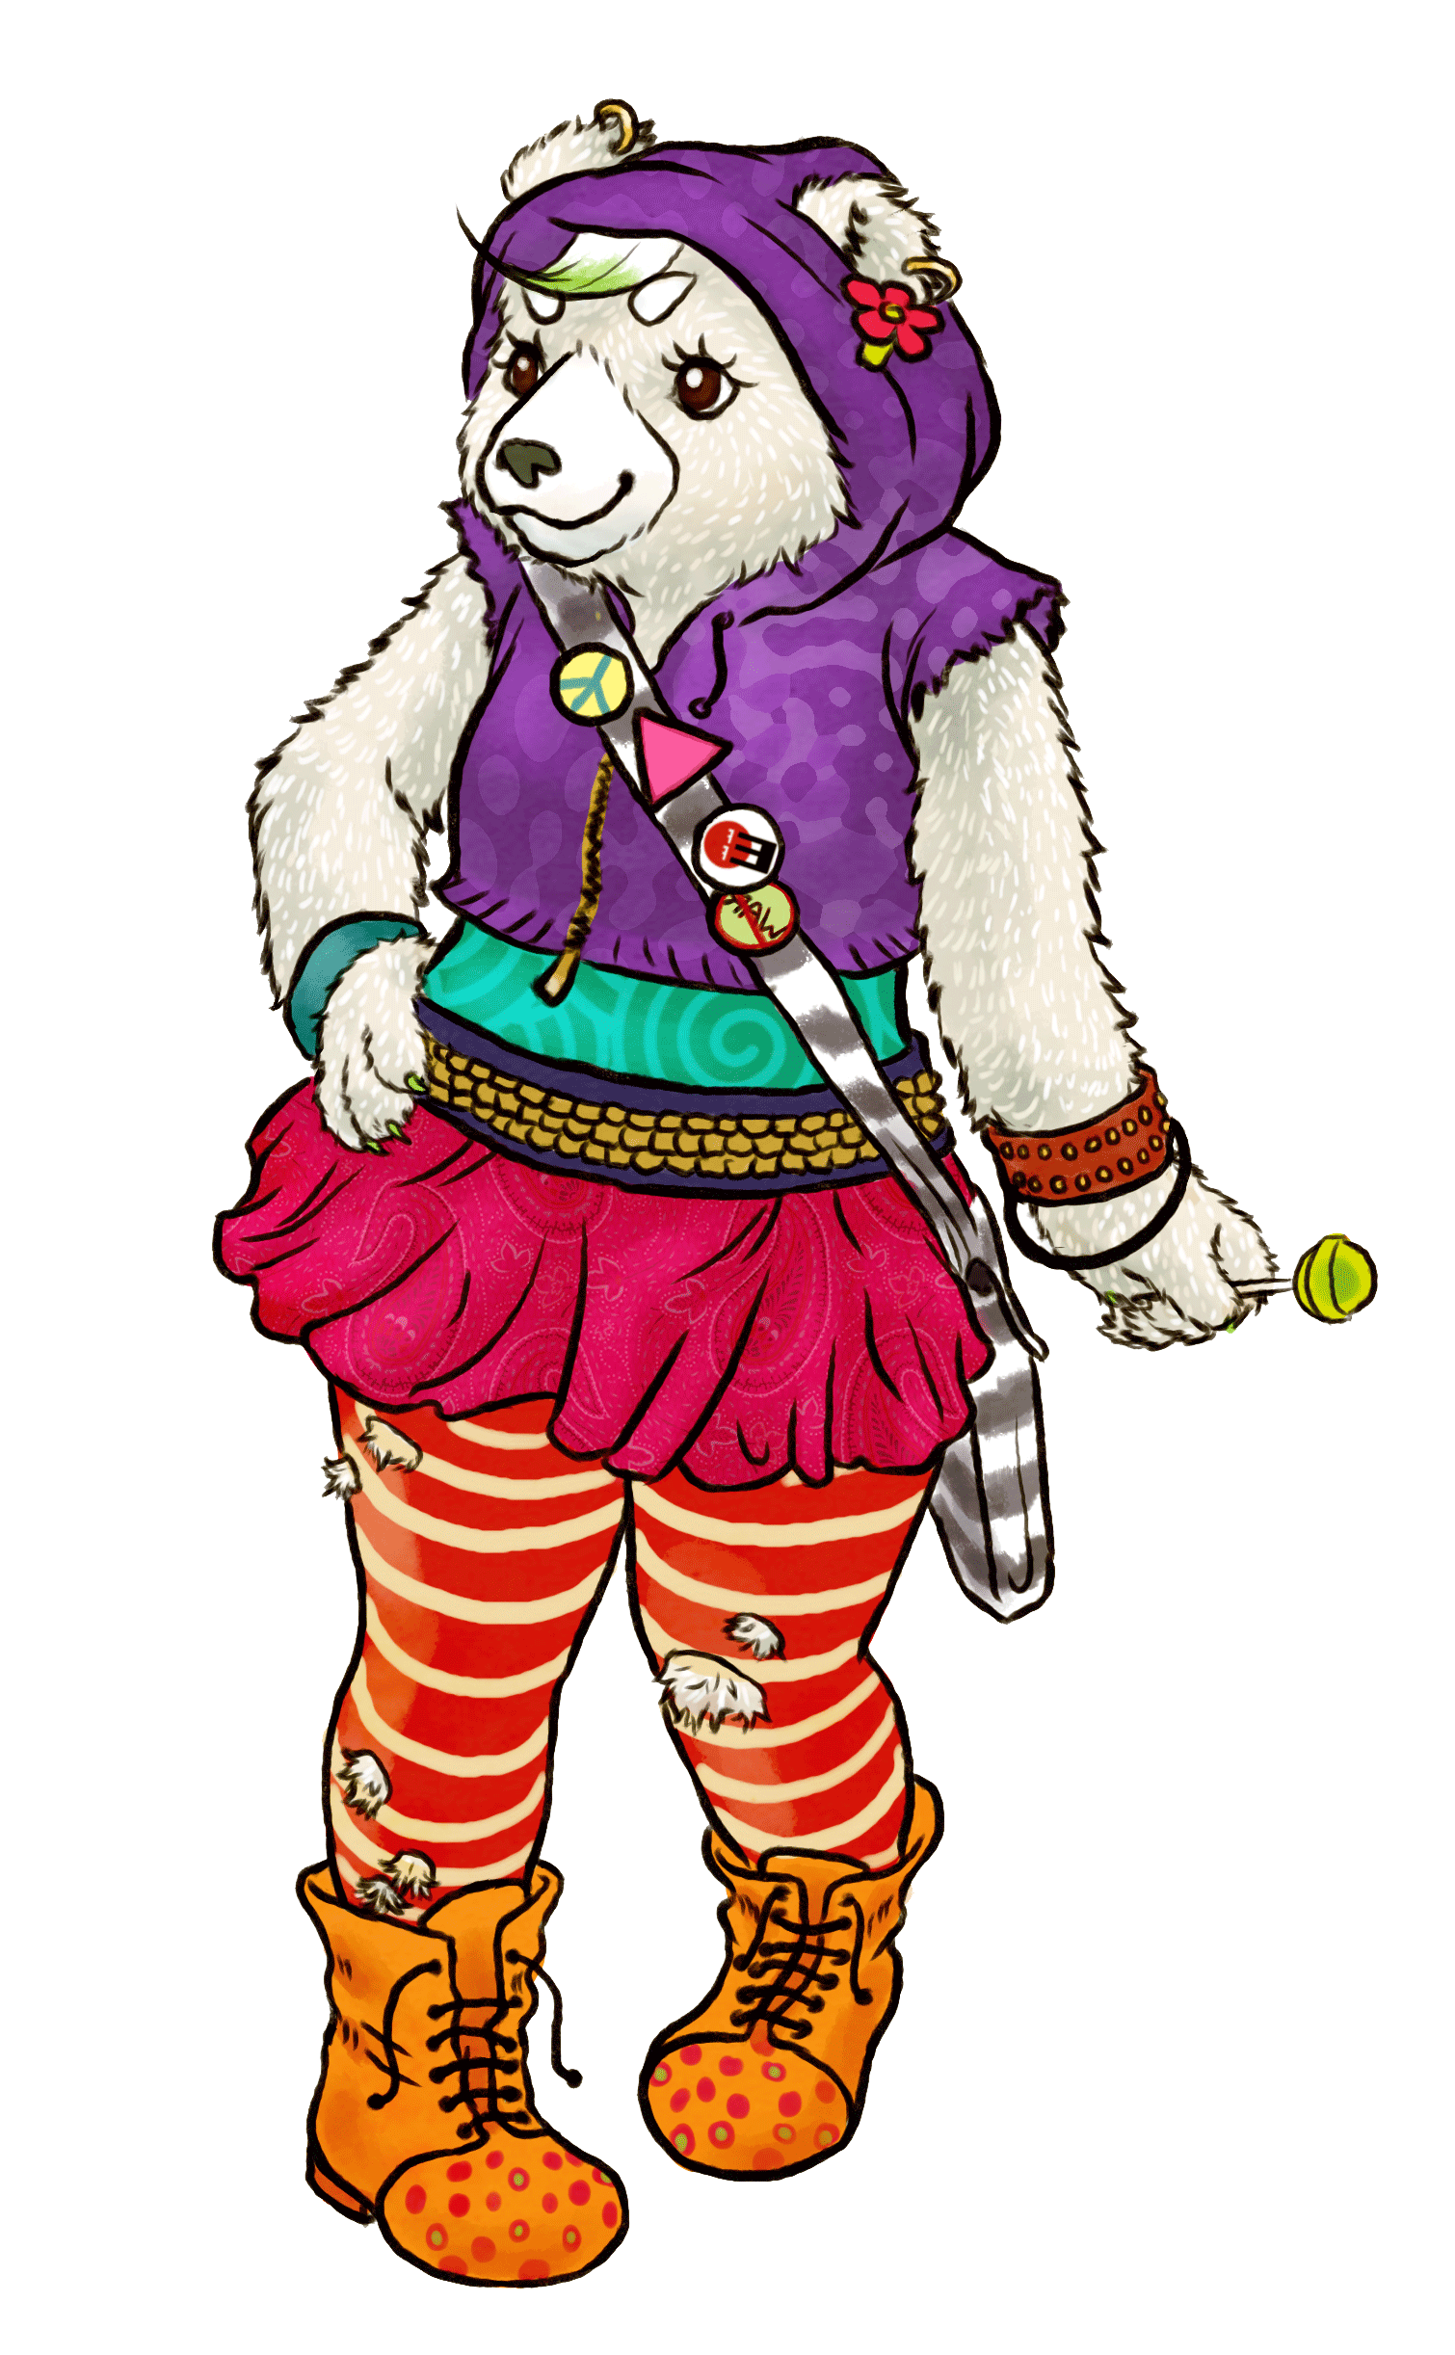
RESEARCHING, TARGETING, AND SUBMITTING
TO YOUR IDEAL EDITOR, ART DIRECTOR OR AGENCY

Do a bit of research and find the names of 5 or more editors, agents, or publishers you would love to work with. What books have they worked on or represented that you like? Why do you want to work with them specifically?
1.

2.

3.

4.

5.

Use this one or create a new table with the name of who you are sending your work to, their email, agency or publisher, planned submission date, actual submission date, response? 3 month later follow up. Remember to also put these dates with reminders in your calendar, as well.
Name | Email | Agency  Publisher | Planned submission date | Actual submission date | Response | 3-month follow up

What kidlit social, craft, or publishing events or classes do you want to attend in January and February this year?

Date | Event | Who will be there | Link | Cost | Follow up

Enjoy these, and as Marsha Diane Arnold says, think of these planners as playsheets rather than worksheets. It will make them much more fun!

